Groundcrew AI stage 5.1

- On the left navigation pane, select Flows and click on “+ New agent flow”

- Choose “ When an agent calls the flow” and add two inputs.
- A text input named “Username”
- Another text input named UserEmail
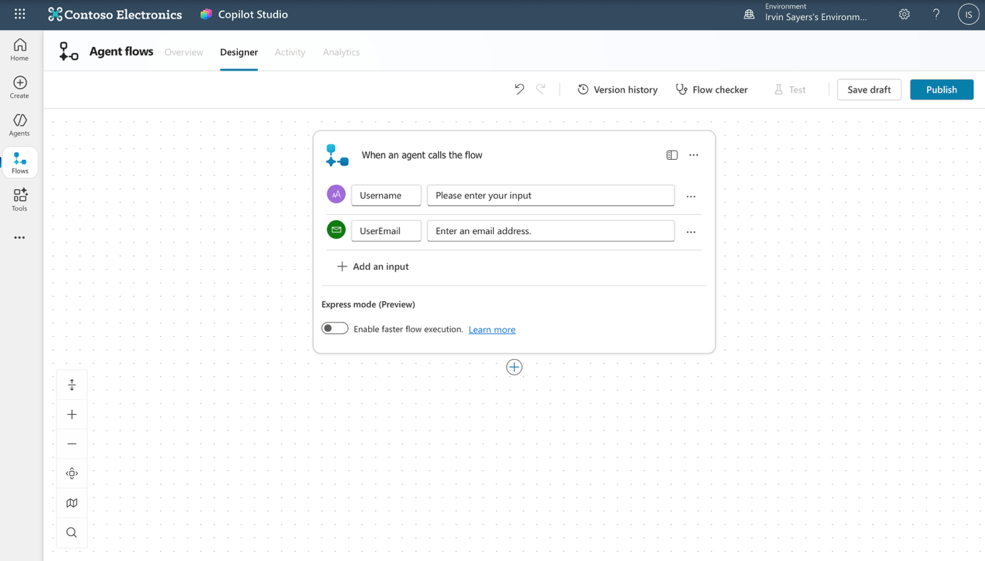

- Click the “+” button below the trigger and add a “Variable > initialize variable”
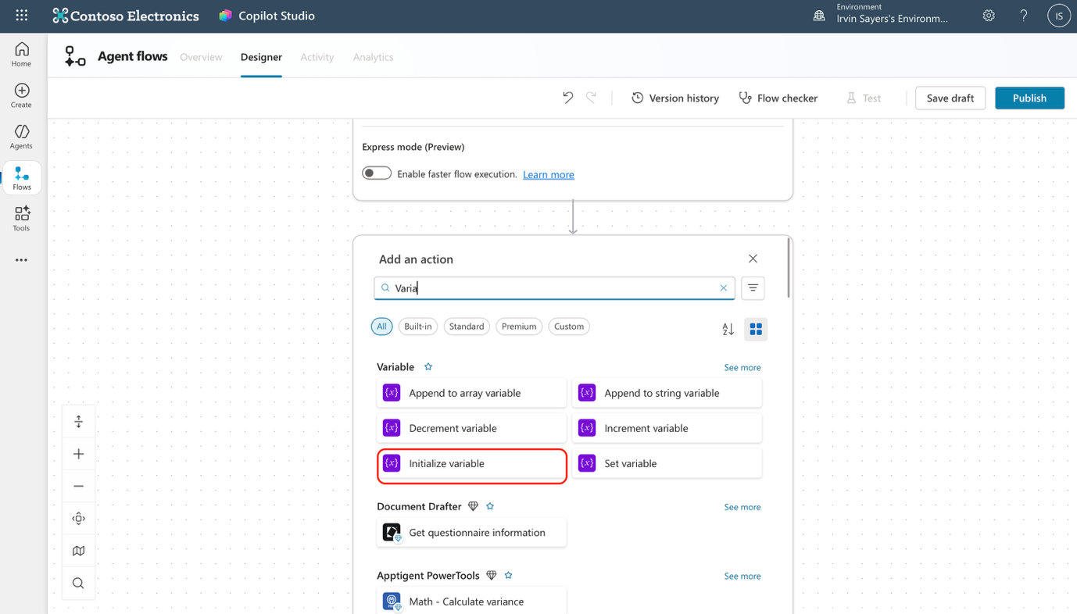

- Configure the variable with the following
Name: Generated Code
Type: Integer
Value: click the “fx” button and input this code “rand(100000,999999)”

- Add another node below, choose “Microsoft Dataverse” and select “Update a row in selected environment”
(If it asks you to sign in to create a new connection, just give the connection any name such as “Groundcrew” and click sign in)
You will then see this node
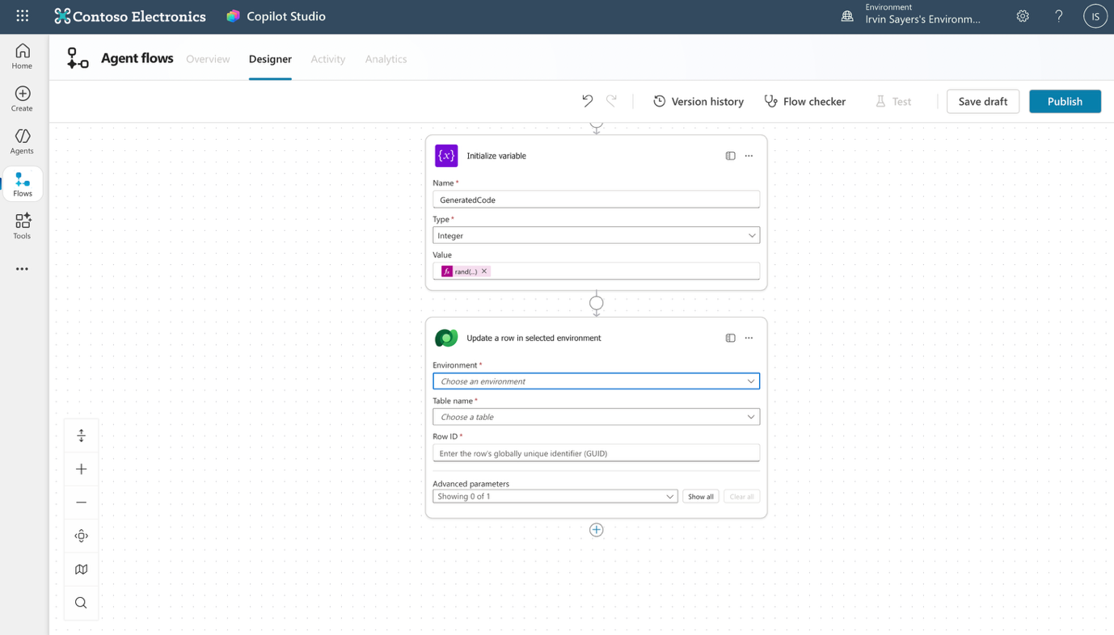

- Configure the Dataverse node
- Environment: use the drop down panel and choose the same environment that your Dataverse table is stored in
- TableName: Search for the “UserVerification” table that you have created and select it

- In order to retrieve your row ID we will have to go to https://make.powerapps.com and view your Userverifications table. The GUID is the column named “Userverification”. This is a unique ID created for that row, You can copy it and paste it onto the “Row ID” in the connecter. Refer to below image.
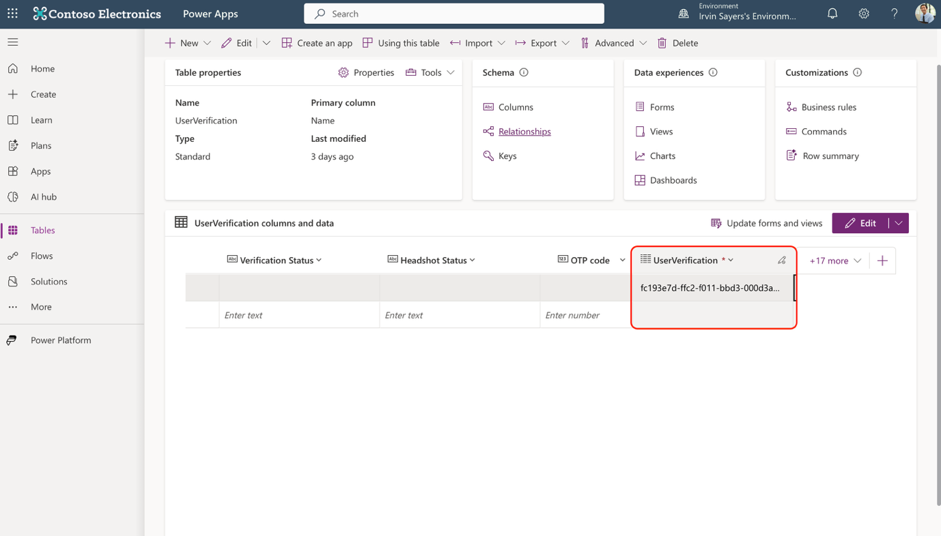

- Once you have retrieved your row ID, paste it onto the Row ID column in your “Update row in selected environment” node, then click on “advanced perimeters and select OTP code. On the OTP code column, click the lightning symbol and input “generatedCode”
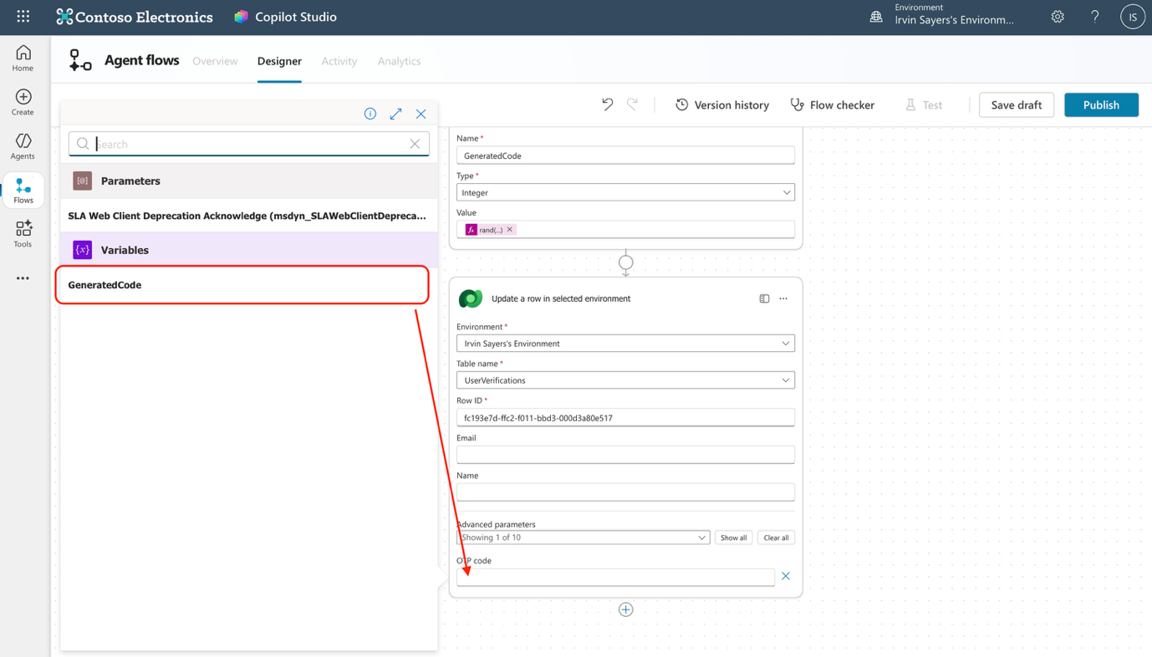

- Below the Dataverse node, add another node. You should add “send an email” node, sign in with your demo credentials if asked to sign in and allow access.
- In the send an email node, configure as follows
TO: Click on the setting buttons and choose, “Use dynamic content” then click the “lightning” symbol and select the “UserEmail” input that you created
Subject: Verification Code
Body: Your verification code is *insert the generated code here*
The node should look like the image below
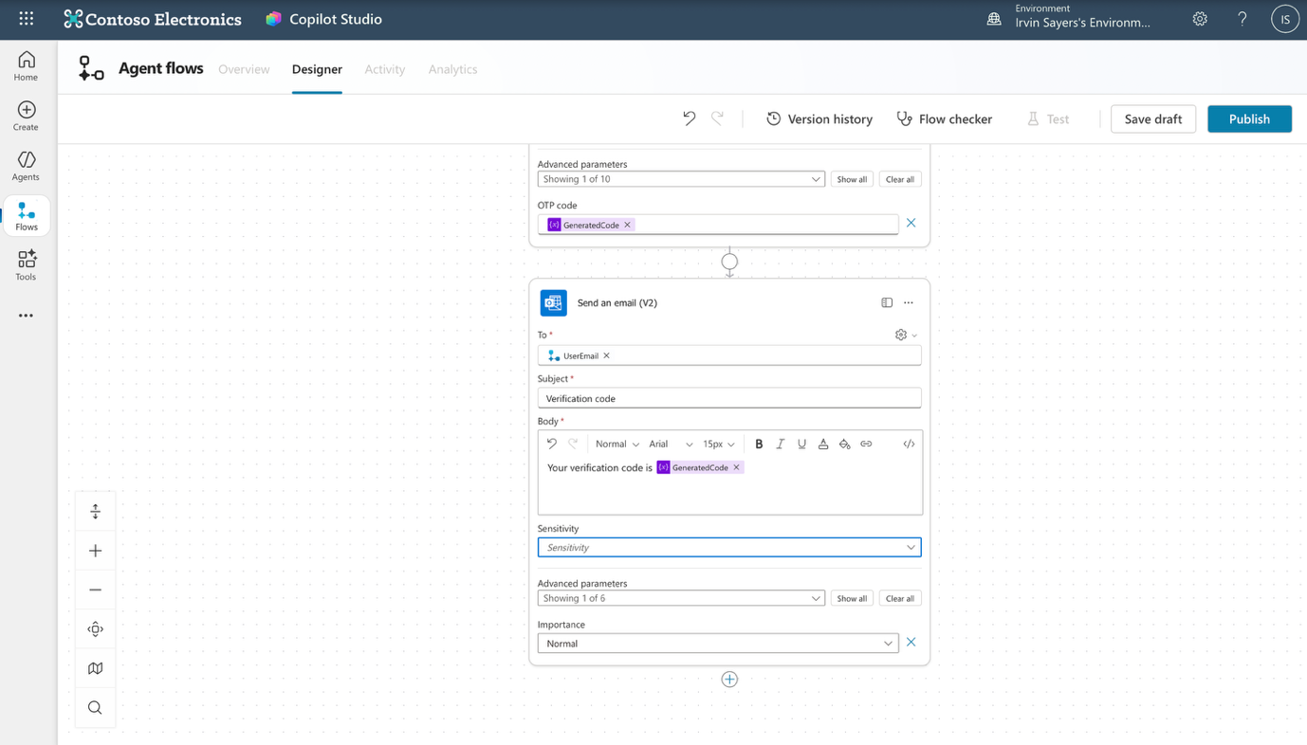

- Add the final action by clicking the “+” button and adding the “respond to agent” node. Click on “+ Add an output” and name it “OTP code”
For it’s value, input “Generatedcode”

- Once done, click publish and go to the overview page. Click edit and change the name of the flow from untitled to “Generate OTP” and the save the flow

- Congratulations, you just built a flow to generate a random six digit number and send it as an email to the user , next we will integrate this flow with the topic!

